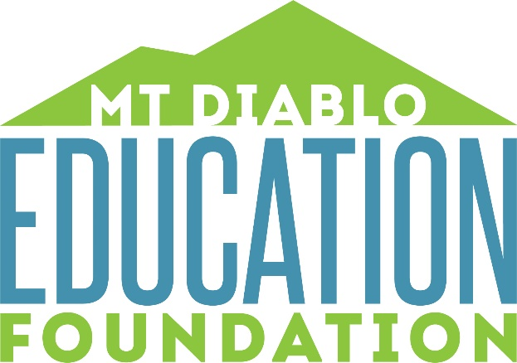

Application for Director
Mt. Diablo Education Foundation

Thank you for your interest in supporting the schools of MDUSD. Please insert your responses then return the updated document via e-mail to info@mdedf.org. All applicants are required to attend at least one Board meeting prior to submitting an application. All applicants will be interviewed. We appreciate your time.

Name:

Phone/email:

City you live in:

Briefly describe your background in any of the following areas, noting any skills or experience that might benefit Mt. Diablo Education Foundation.

- Volunteer/Community Service Experience:

- Community Outreach/Organizing:

- Governing Boards:

- Non-Profit Management or Foundation/Philanthropic Work:

- Fundraising:

- Marketing:

- Are you bilingual?

- Committee Experience (as a member or the chair):

Briefly describe your familiarity with each of the following:

- MDUSD – programs, sites, staff, parent

- MDUSD Education Foundation

- Local business or professional organizations

- Community groups

Please briefly respond to the following questions:

- Why are you interested in serving on our Board of Directors?

- What do you hope to accomplish as a member of the Board?

- Are you available to regularly attend monthly meetings, special meetings that are
scheduled periodically as circumstances require, and committee meetings?

- What type of on-going committee work would you prefer to do? Do you envision
yourself as committee member or chairperson?

- Please list any special skills or experience you will bring to our organization.

